**Part 1 — Customer Database Analysis (50 points)**

Complete the following queries using the customers, orders, and Router_info data. You should submit your queries and output in a word document. You will also be graded on creativity and complexity.

**1. Import the data into SQlite by creating 3 tables to host the data (10 points)**

**TABLE 1**

CREATE TABLE orders(

OrderID INTEGER NOT NULL,

CustomerID INTEGER NOT NULL,

SKU CHAR NOT NULL,

Description CHAR NOT NULL,

Cost INTEGER NOT NULL,

Year_Purchase INTEGER NOT NULL,

PRIMARY KEY (OrderID),

FOREIGN KEY(CustomerID) REFERENCES Router_Info(CustomerID)

);

.mode csv

.import /Users/yanlingzhou/Downloads/orders.csv orders



**TABLE 2**

CREATE TABLE IF NOT EXISTS Router_Info(

RMAID INTEGER NOT NULL,

OrderID INTEGER NOT NULL,

Status CHAR NOT NULL,

Step CHAR NOT NULL,

Reason, CHAR NOT NULL,

CustomerID INTEGER NOT NULL PRIMARY KEY AUTOINCREMENT,

FOREIGN KEY (OrderID) REFERENCES orders(OrderID)

);

.mode csv

.import /Users/yanlingzhou/Downloads/Router_Info.csv Router_Info

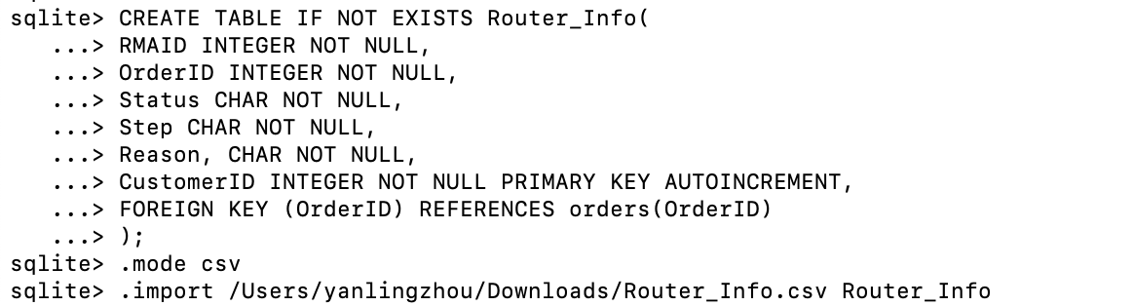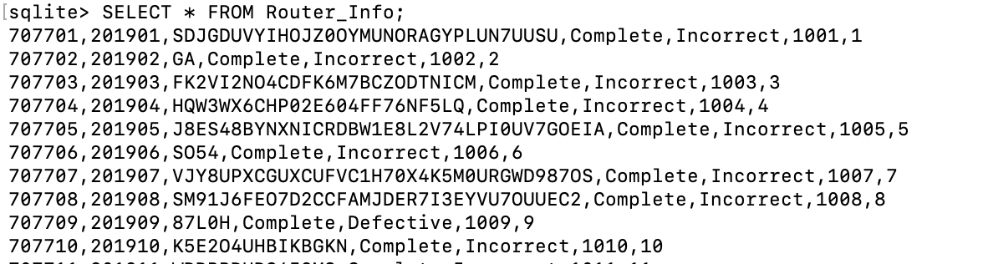

**TABLE 3**

CREATE TABLE customers (

CustomerID INTEGER,

FirstName TEXT,

LastName TEXT,

StreetAddress TEXT,

City TEXT,

State TEXT,

ZipCode INTEGER,

Telephone TEXT,

Purchases_Total INTEGER,

FOREIGN KEY(CustomerID) REFERENCES Router_Info (CustomerID),

PRIMARY KEY(FirstName, LastName)

);

.mode csv

.import /Users/yanlingzhou/Downloads/customers.csv customers

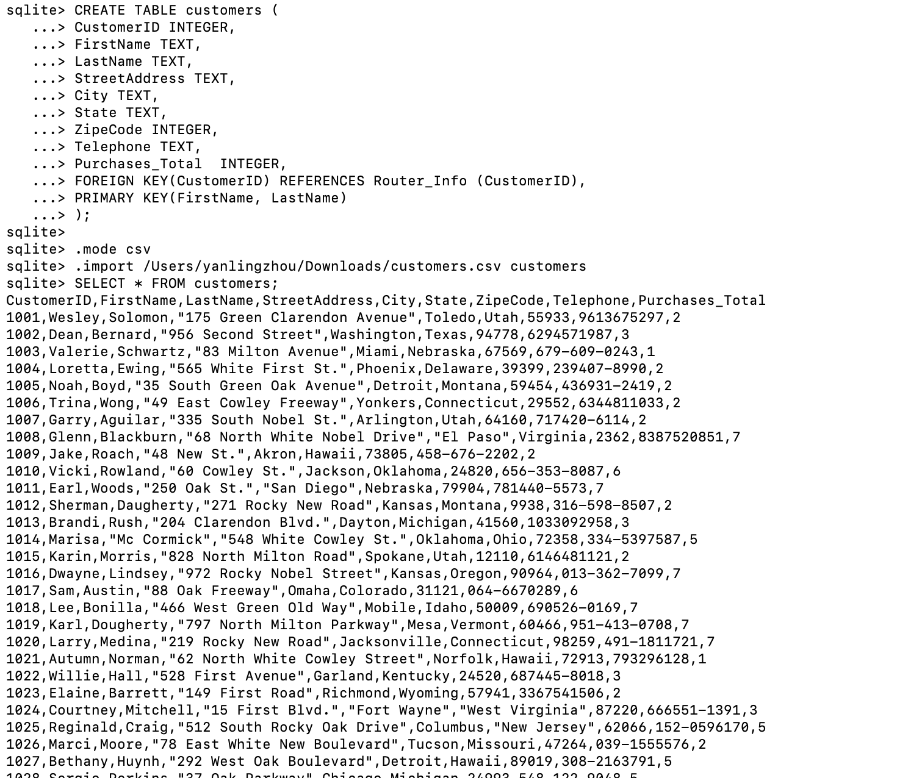

**2. Explore the data, what do you see and how would you connect all 3 of these**

**tables? (2.5 points)**

According to all three tables, both table “orders” and “Routers_info” share the same “order ID” and “customer ID”, while the “customers” table only shares the “customer ID” with the other two tables. Since the “order ID”, “customer ID” and the combination of “First name” and “last name” are unique in each table, we set :

Orders table: “order ID” as the primary key (PK), “customer ID” as the foreign key (FK).

Routers_info table: “customer ID” as the PK, “order ID” as the FK.

Customers table: the combination of “First name” and “last name” as the PK, and “customer ID” as the foreign key (FK).

Below are the queries used to identify the primary key of each table (the primary keys are the one with the last column (PK) return 1 or 2):

SELECT * FROM PRAGMA_table_info ('orders');

SELECT * FROM PRAGMA_table_info ('Router_Info');

SELECT * FROM PRAGMA_table_info ('customers');

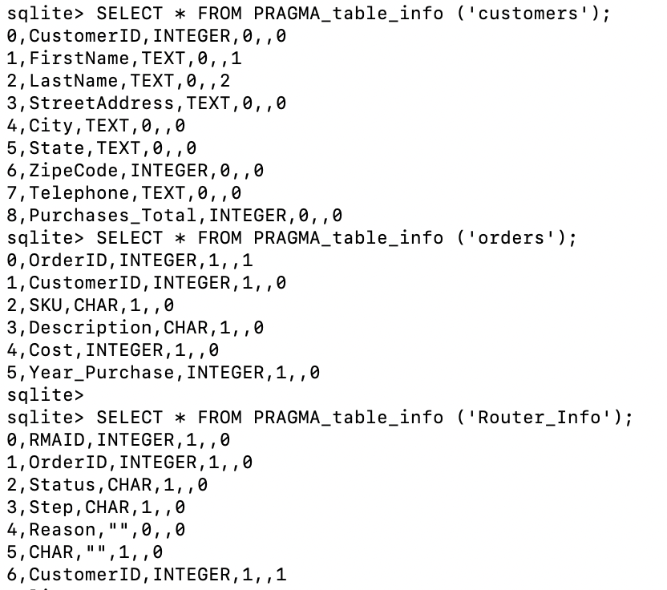

Below are the queries to return all foreign keys:

SELECT * FROM PRAGMA_foreign_key_list ('orders');

SELECT * FROM PRAGMA_foreign_key_list ('Router_Info');

SELECT * FROM PRAGMA_foreign_key_list ('customers');

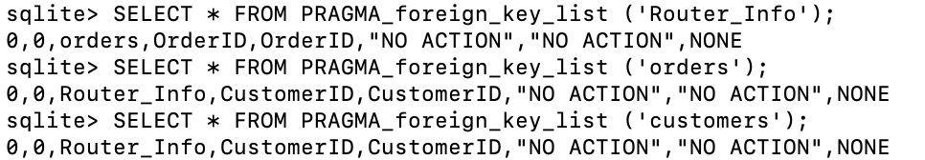

**3. Create a query using Select, where, from on a table of your using (2.5 points)**

SELECT *

FROM customers

WHERE Purchases_Total > 3

ORDER BY Purchases_Total DESC;

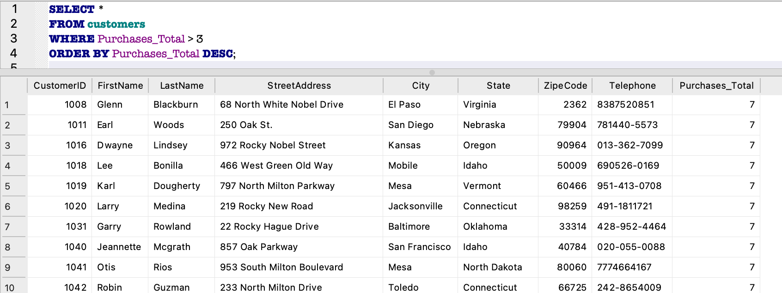

**Explanation:** This query displays customers whose “purchase_total” is greater than 3 with a descending order.

**4. Create a query that joins the tables (5 points)**

SELECT *

FROM orders

LEFT JOIN Router_Info

USING (CustomerID, OrderID)

LEFT left JOIN customers

USING (CustomerID);

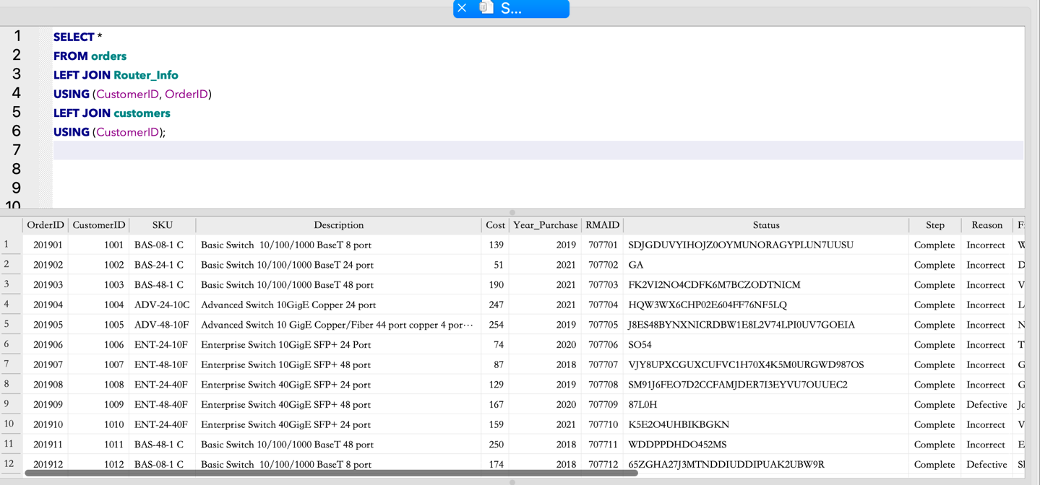

**Explanation:** This query joins “Router_Info”, “orders” and “customers” into one table.

**5. Create a left join query (0 points)**

Please see the answer of question 4

**6. Create a query that uses the joined data from question 2 and includes Group BY, HAVING, Order By (5 points)**

SELECT Cost, FirstName, LastName, City, State, Telephone

FROM orders

LEFT JOIN Router_Info

USING (CustomerID, OrderID)

left JOIN customers

USING (CustomerID)

GROUP BY State

HAVING Cost>= 60

ORDER BY Cost DESC;

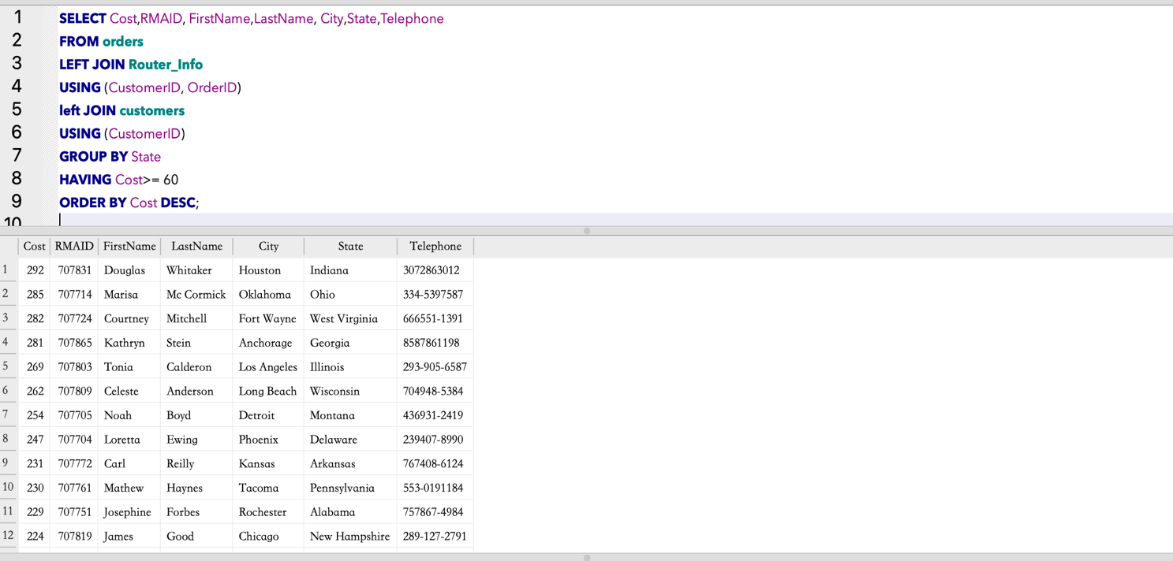

**Explanation:** This query shows the RMAID and contact information of customers who’s order cost is 60 or greater.

**7. Create a query that counts and distinctly counts (5 points)**

SELECT COUNT (DISTINCT Year_Purchase) AS Distinct_Year_Purchase FROM orders;

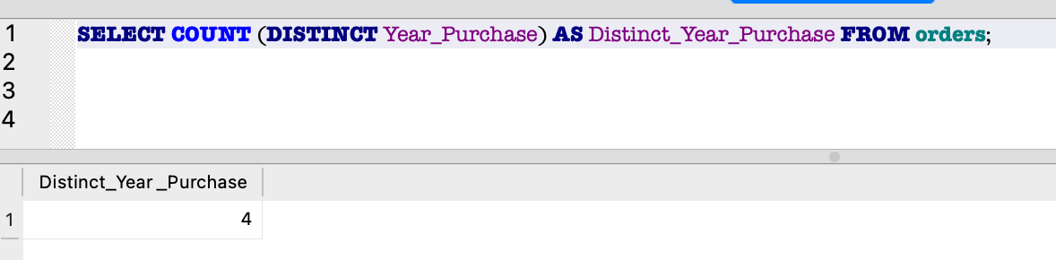

**Explanation:** This query shows the number of “year_purchase” that is distinct in the “orders” table, which is 4. This means the table contains data from 4 distinct years.

**8. Create a query that finds the MIN, MAX, Sum, order by desc (5 points)**

SELECT SUM(Purchases_Total), MAX(Purchases_Total), MIN(Purchases_Total), State

From customers

GROUP BY State

ORDER BY SUM(Purchases_Total) DESC;

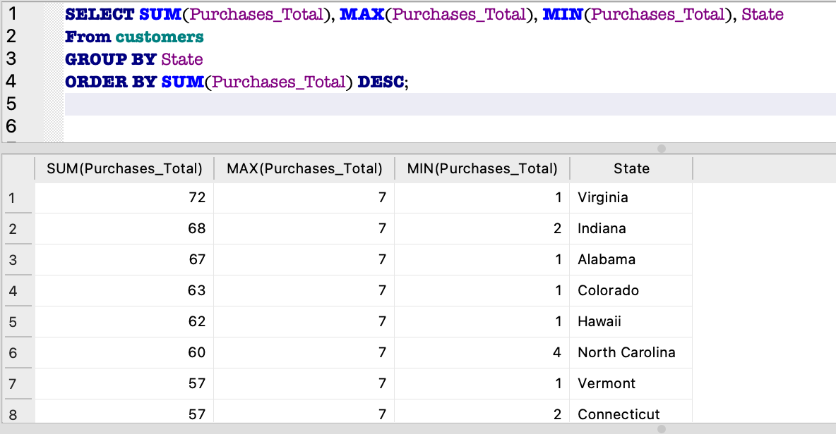

**Explanation:** This query finds the sum, maximum, and minimum of “purchase_total” of each States, and is ordered by the sum of “purchse_total” from highest to lowest.

**9. Create a query that uses Between, and, <, > (5 points)**

SELECT OrderID,SKU, Description, Year_Purchase, CustomerID, Cost

from orders

WHERE (Year_Purchase BETWEEN 2019 AND 2021) AND (Cost >200 OR Cost < 50)

ORDER BY Cost;

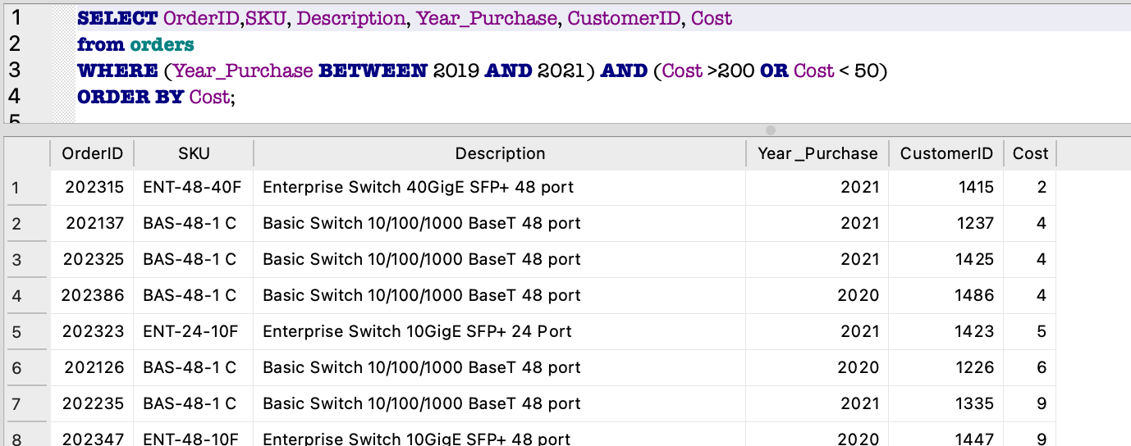

**Explanation:** This query lists the SKU and Description of routers that cost less than 50 or greater than 200. Accompanied by information on CustomerID, OrderID, and Year that was purchased, and is listed by the Cost in an ascending order.

**10. Create a query that uses a wildcard, a join, and a group by clause (5 points)**

SELECT FirstName, LastName, Year_Purchase, State, Purchases_Total

FROM customers

LEFT JOIN orders

USING (CustomerID)

WHERE state LIKE '%NEW%'

GROUP BY Year_Purchase;

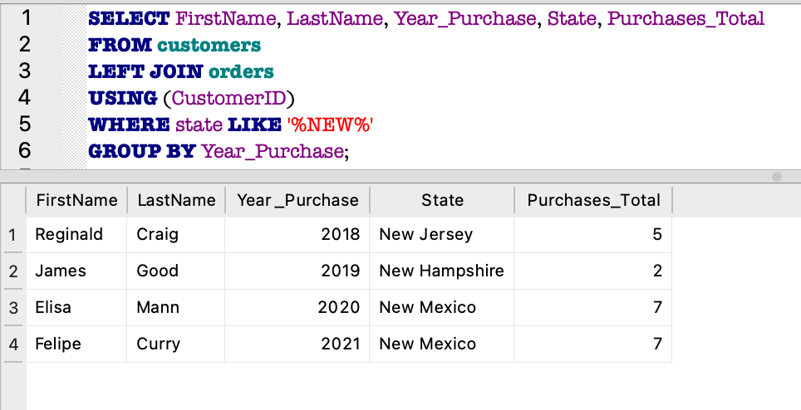

**Explanation:** This query lists purchase information including year and purchase_total, it also gives us customers’ name and State resided.

**11. Create a query that finds the average and uses one of the following AND, OR, NOT (5 points)**

SELECT State, CustomerID, ROUND(AVG(Purchases_Total),2) AS average_total

FROM orders

LEFT JOIN customers

USING (CustomerID)

WHERE State IS  NOT 'Texas'

GROUP BY State;

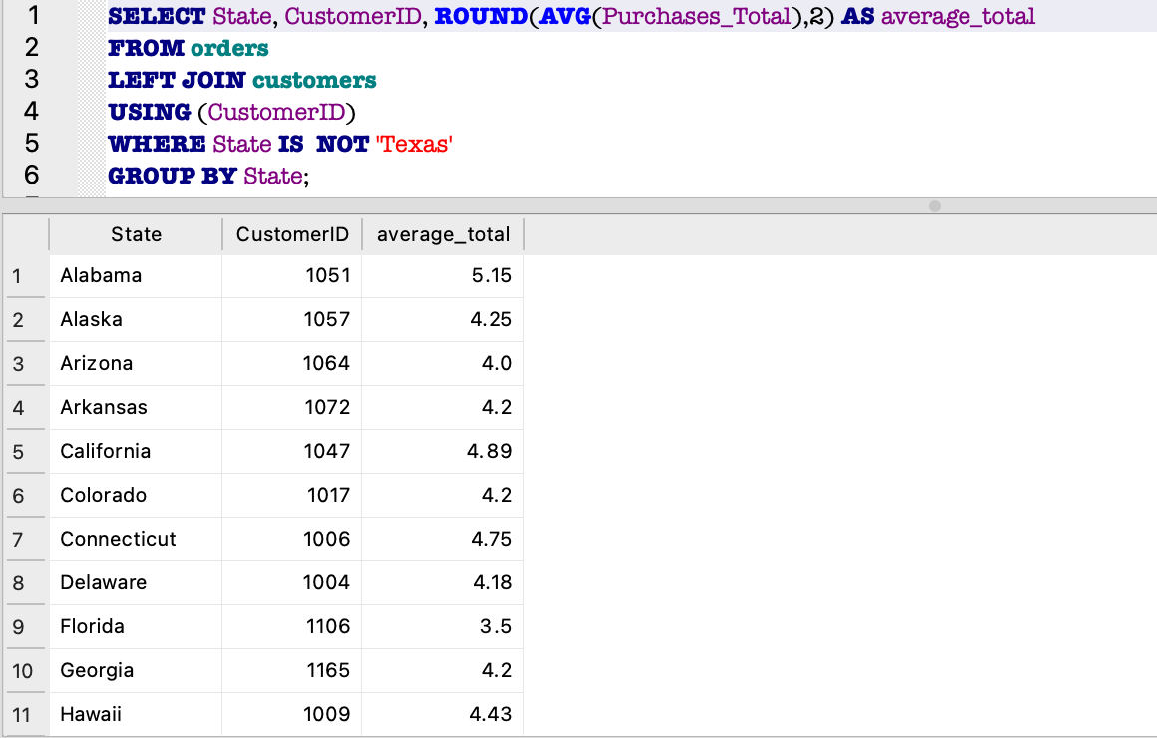

**Explanation**: This query shows the average “purchase_total” of every States except Texas.

-------------------------------------------------

**Part 2 — HIV Database Analysis (50 points)**

**1.Look at both data sets what do you observe? How would you join the data? (5 points)**

CREATE TABLE IF NOT EXISTS country_info(

Country TEXT NOT NULL,

Year INTEGER NOT NULL,

Country_Population DOUBLE NOT NULL,

GDP_per_capital DOUBLE NOT NULL,

unemployment_rate DOUBLE NOT NULL,

School_enrollment_rate DOUBLE NOT NULL,),

PRIMARY KEY(Country, Year));

PRIMARY KEY(Country, Year);

.mode csv

.import -skip 1 /Users/yanlingzhou/Downloads/country_info.csv country_info

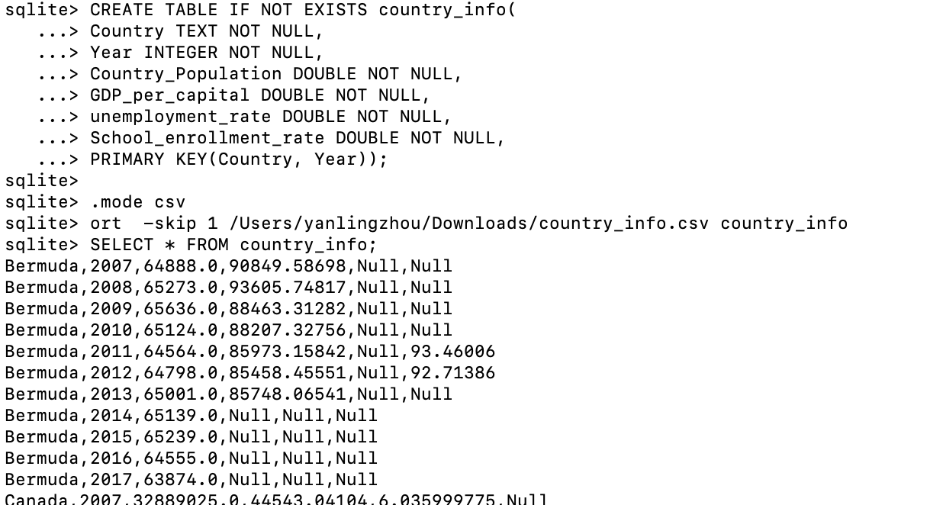

.import  -skip 1 /Users/yanlingzhou/Downloads/country_info.csv country_info

CREATE TABLE IF NOT EXISTS HIV_info(

Country TEXT NOT NULL,

CREATE TABLE IF NOT EXISTS country_info(

Country TEXT NOT NULL,

Year INTEGER NOT NULL,

Country_Population DOUBLE NOT NULL,

GDP_per_capital DOUBLE NOT NULL,

unemployment_rate DOUBLE NOT NULL,

School_enrollment_rate DOUBLE NOT NULL),

PRIMARY KEY(Country, Year);

.mode csv

.import  -skip 1 /Users/yanlingzhou/Downloads/country_info.csv country_info

CREATE TABLE IF NOT EXISTS HIV_info(

Country TEXT NOT NULL,

Year INTEGER NOT NULL,

Living_with_HIV DOUBLE NOT NULL,

Death_lessthan_5 DOUBLE NOT NULL,

Infected_with_HIV DOUBLE NOT NULL,

FOREIGN KEY("Year") REFERENCES "country_info"("Year"),

FOREIGN KEY("Country") REFERENCES "country_info"("Country"));

Death_greater_equal_70 DOUBLE NOT NULL,

Death_5_to_14 DOUBLE NOT NULL,

Death_15_to_49 DOUBLE NOT NULL,

Death_50_to_69 DOUBLE NOT NULL,

Death_total DOUBLE NOT NULL,

New_infection DOUBLE NOT NULL,

Infected_with_HIV DOUBLE NOT NULL),

FOREIGN KEY(Country,Year) REFERENCES country_info(Country,Year);

.mode csv

.import -skip 1 /Users/yanlingzhou/Downloads/HIV_info.csv HIV_info

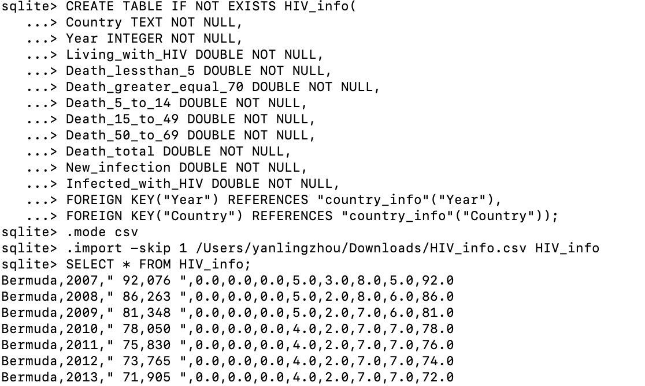

SELECT * FROM country_info LEFT JOIN HIV_info using (Country,Year);

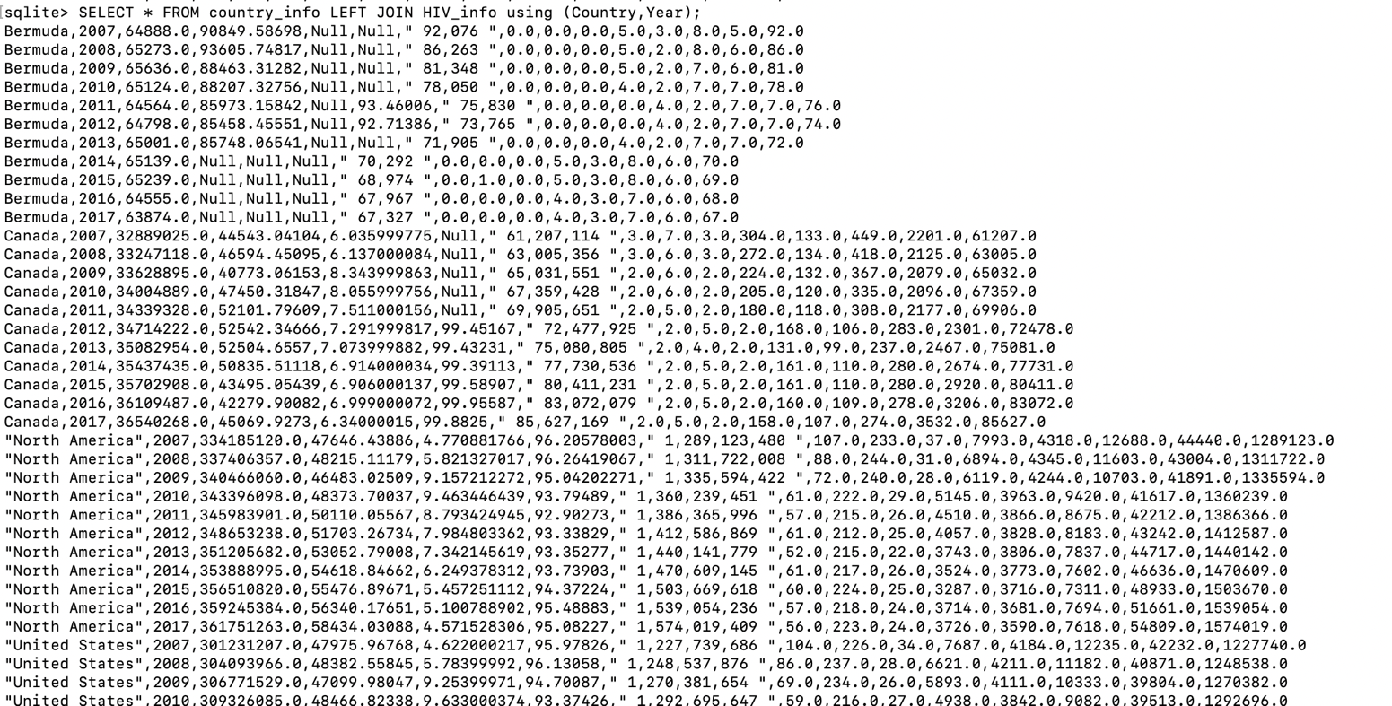

**Explanation:** The country_info dataset contains six variables which are: country, year, country population, GDP per capital, unemployment rate, school enrollment rate. The HIV_info dataset has 11 variables which are: Country, Year, Living with HIV, Death less than 5, Death 5 to 14, Death 15 to 49, Death 50 to 69, Death greater or equal 70, Death total, New infection, Infected with HIV. Both datasets have the variables country and Year, therefore, the duplicate variables are removed when join the data. Because we want to keep all the data from both data sets, and full outer join CANNOT be used in sqlite, we choose to use outer(left) join to join the data.

**2. Select the Country, Year, new_cases_of_hiv_infection, and School_enrollment_rate then join the data hiv_info to the country_info table on Entity/Country and year for only North America (10 points)**

SELECT Country, Year, New_infection, School_enrollment_rate

FROM country_info

LEFT JOIN HIV_info

USING (Country,Year)

WHERE Country= 'North America';

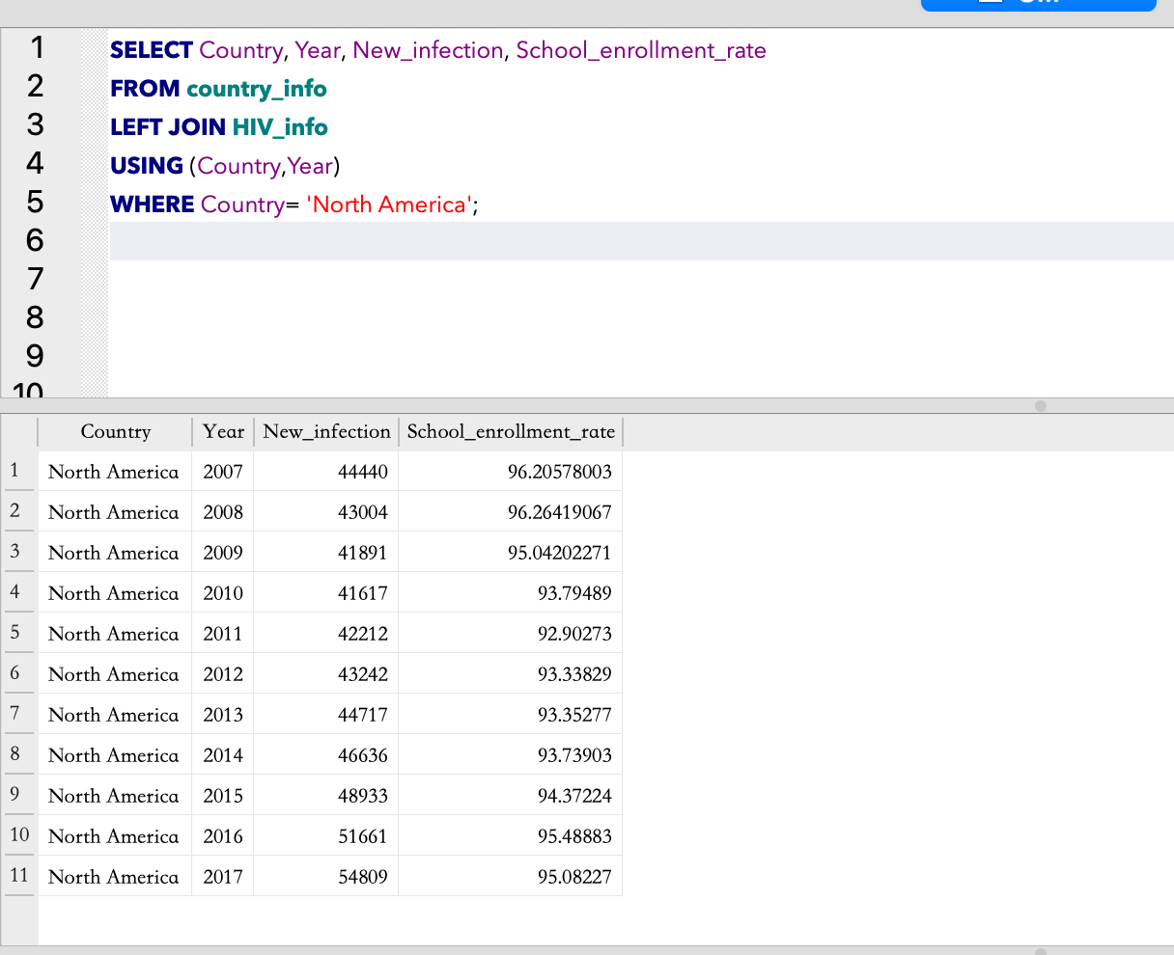

**Explanation:** This query displays the New infection, school enrollment rate for North America from year 2007 to 2017.

**3. Select columns Country, Year, Country_Population and get the percentage of people living with HIV and percentage of deaths from HIV then join the data hiv_info to the country_info table on Entity/Country and year for only North America (10 points)**

SELECT Country, Year, Country_Population,

((Infected_with_HIV)/(REPLACE(Living_with_HIV, ',' , ''))*100) AS Living_with_HIV_percentage,

((Death_total)/ (REPLACE(Living_with_HIV, ',' , '') )*100) AS Death_from_HIV_percentage

FROM HIV_info

LEFT JOIN country_info

USING (Country, Year)

WHERE Country='North America';**output :**

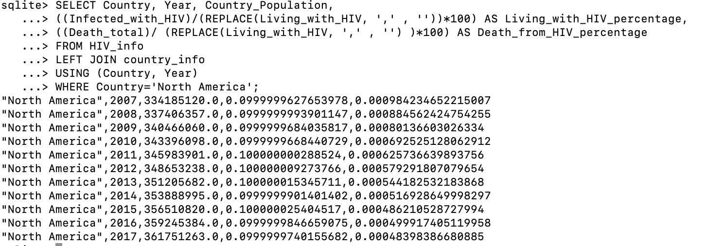

**Explanation:** This query shows the year, country population, percentage of the people living with HIV, percent of people die from HIV in the North America. Data are generated from both the HIV_info dataset and the country _info dataset by left join both tables.

**4. Select columns Country and get the SUM of the number_of_people_living_with_HIV divided by Country_Population then join the data hiv_info to the country_info table on Entity/Country and year not in North America (10 point)**

SELECT Country, SUM(REPLACE(Living_with_HIV, ',' , '')/Country_Population)

FROM HIV_info

LEFT JOIN country_info

USING (Country, Year)

WHERE Country IS NOT 'North America'

GROUP BY (Country);

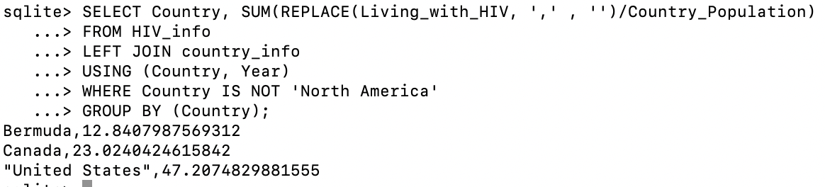

**Explanation:** This query shows the sum of people living with HIV divided by country population among the countries that are not North America.

**5. Produce 5 unique and interesting queries using both datasets. Unique means that you do not use the same query 5 times and add small parts to it. (15 points, 3 points each)**

CREATE TABLE Country_HIV_info AS

SELECT * FROM country_info JOIN HIV_info using (Country,Year);

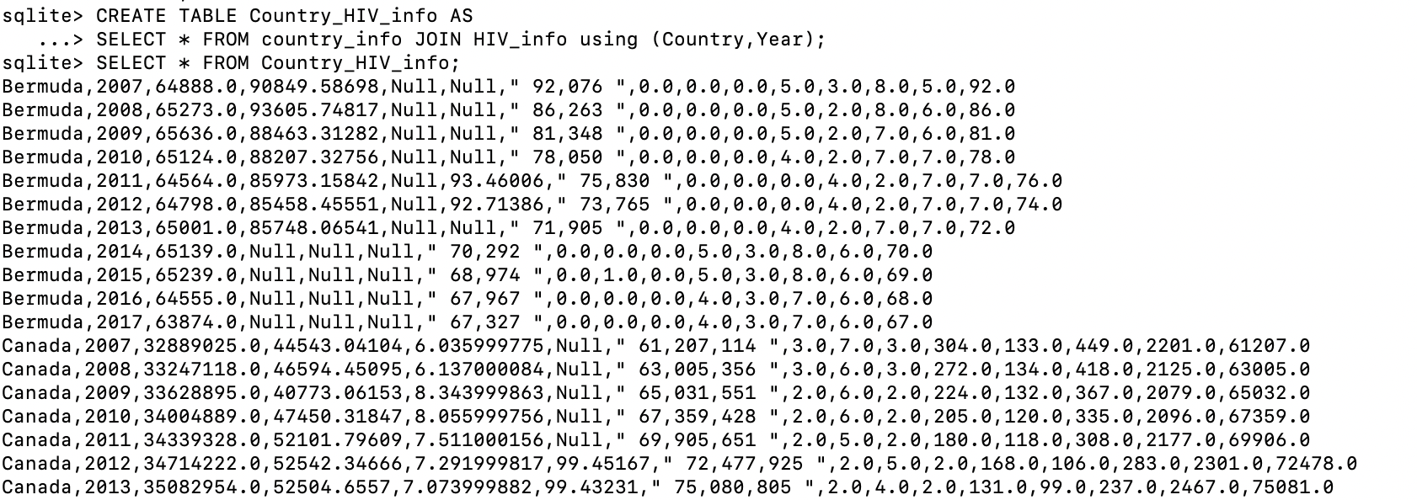

**Explanation:** Since this question require us to use both datasets, we join both data together and create a new table named “Country_HIV_info”.

1)

SELECT GDP_per_capital, Country, Year, Death_total

FROM Country_HIV_info

WHERE GDP_per_capital !='Null'

ORDER BY GDP_per_capital DESC;

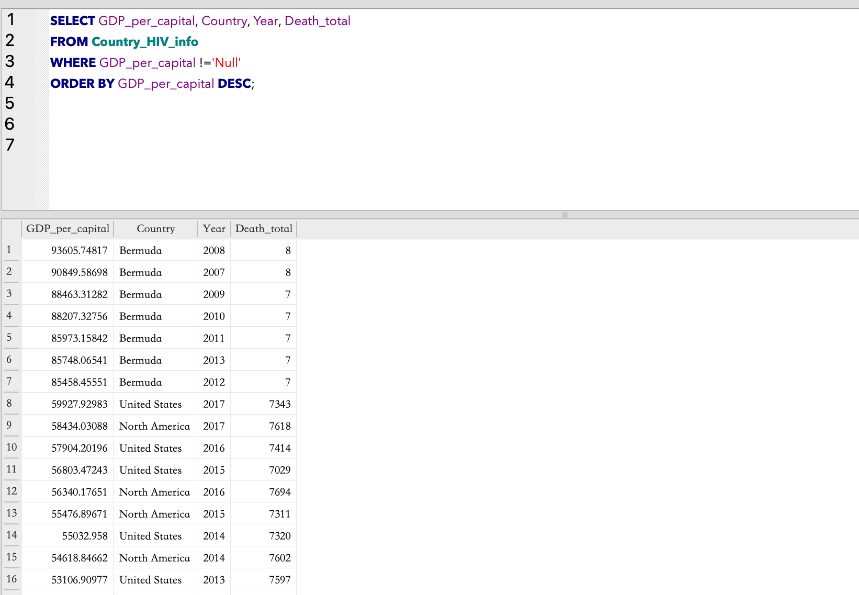

**Explanation:** This qurey organizes GDP_per_capital data from highest to lowest while it is accompanied by country, year, and death_total information.

2)

SELECT Country, Year, New_infection, unemployment_rate

FROM Country_HIV_info

WHERE Year >= 2010 AND unemployment_rate IS NOT 'Null';

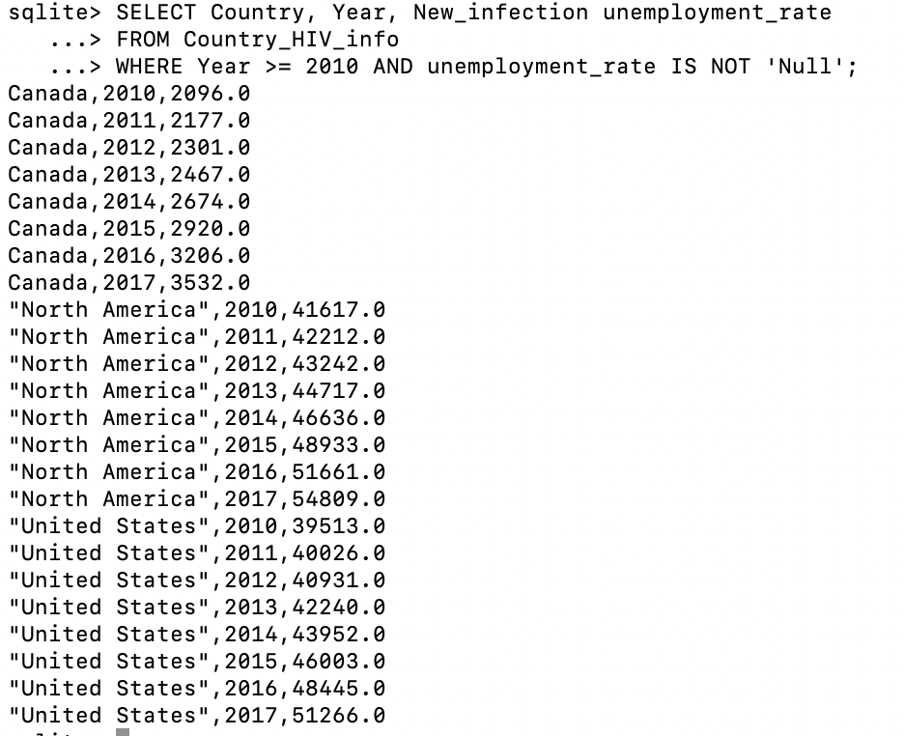

**Explanation:** This queryshows theCountry, year, new infection rate, unemployment rate in the year 2010 or later, the data with has “Null” for unemployment rate are excluded.

3)

SELECT MAX (REPLACE(Living_with_HIV, ',' , '')), Country, School_enrollment_rate,Year

From Country_HIV_info

WHERE (REPLACE(Living_with_HIV, ',' , '')) NOT IN (SELECT MAX (REPLACE(Living_with_HIV, ',' , ''))

FROM Country_HIV_info)

GROUP BY Country;

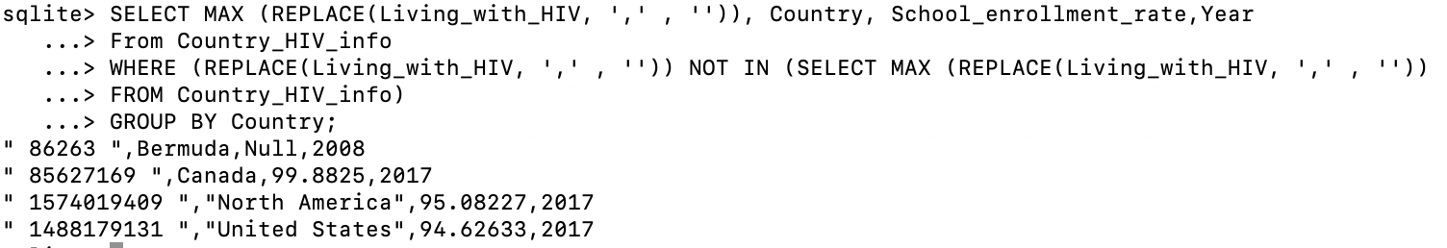

**Explanation:** This query displays the number of people living with HIV, year, school enrollment rate for the second highest number of people living with HIV in each country.

4)

SELECT Country, Year, Infected_with_HIV,

(Infected_with_HIV -LAG(Infected_with_HIV, 1) OVER (PARTITION BY Country) ) as infected_difference_from_previous_year,

unemployment_rate,

(unemployment_rate- LAG(unemployment_rate, 1) OVER (PARTITION BY Country)) AS unemployment_difference

from Country_HIV_info;

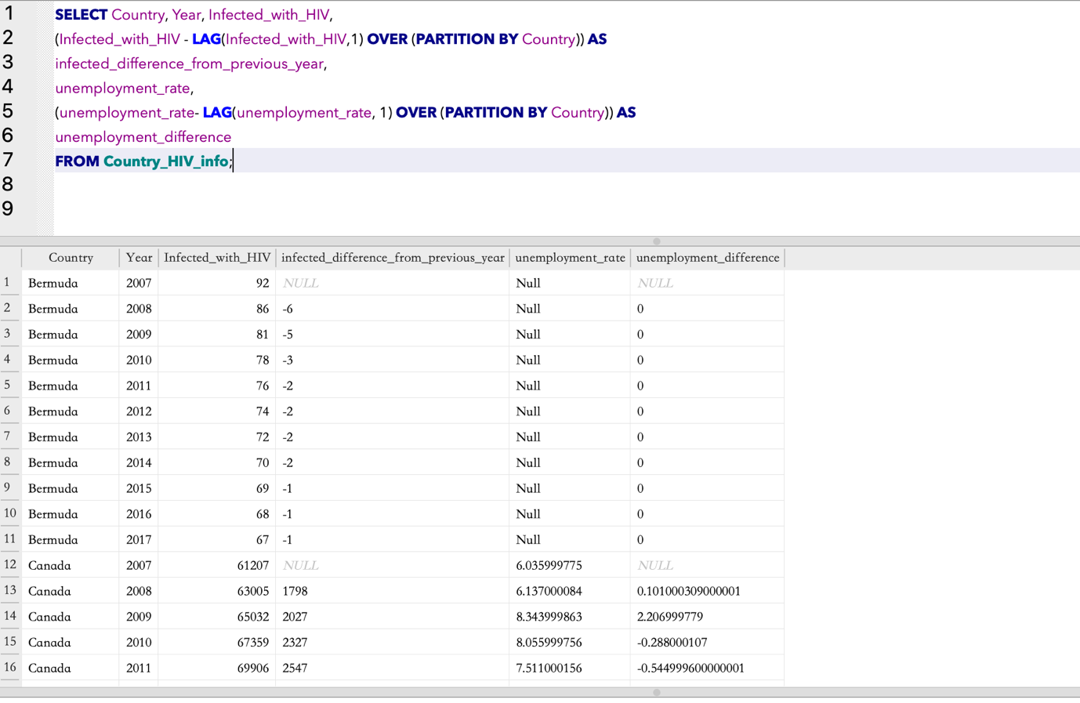

**Explanation:** this query creates two new columns: “infected_differece_from_previous_year” and “unemployment_difference”.

- “infected_differece_from_previous_year” shows the yearly change/differences of the number of people infected with HIV in each country. For example, from 2007 to 2008, the total number of people infected with HIV in Bermuda was decreased by 6.

- “unemployment_difference” shows the yearly differences in unemployment_rate for each country.

5)

SELECT Country, Year, Infected_with_HIV,

RANK()OVER (ORDER BY Infected_with_HIV DESC)Rank

FROM Country_HIV_info

WHERE Year IS NOT 2007;

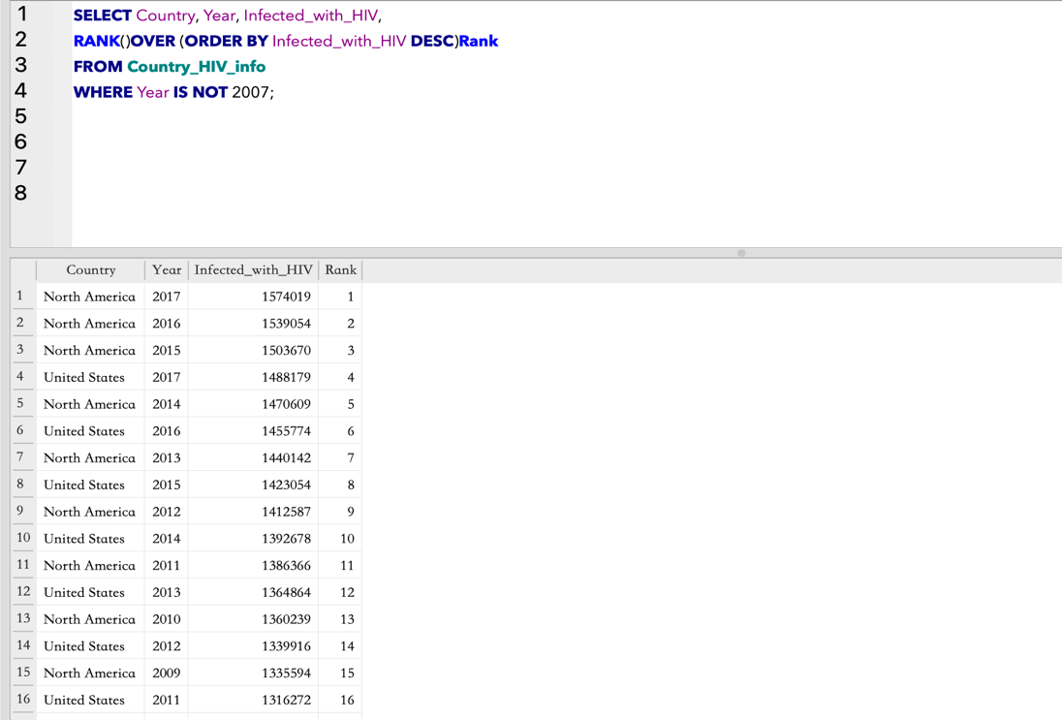

**Explanation:** This query ranks the number of people infected with HIV from all countries and years, except 2007.